Ch 18. Post-harvest Contamination
Table 18.1. A partial list of post harvest fungi that affect Cannabis. All of these may cause losses due to rot and spore contamination. Some pose human health threats as producers of mycotoxins or as direct human pathogens.

Kingdom: | Fungi | Fungi | Fungi | Fungi | Fungi
Phylum: | Ascomycota | Ascomycota | Ascomycota | Ascomycota | Mucoromycotina
Class: | Leotiomycetes | Eurotiomycetes | Eurotiomycetes | Sordariomycetes | Zygomycetes
Order: | Helotiales | Eurotiales | Eurotiales | Hypocreales | Mucorales
Family: | Sclerotiniaceae | Trichocomaceae | Trichocomaceae | Nectriaceae | Mucoraceae
Genus: | Botrytis | Aspergillus | Penicillium | Fusarium | Rhizopus
Species: | Botrytis cinerea | Aspergillus flavus, A. niger, | Penicillium citrinum, P. paxilli, P. commune, P. copticola | Fusarium oxysporum,  F. solani, F. equiseti | Rhizopus stolonifer

In addition to contaminating living Cannabis plants, there are a number of fungi that can grow on Cannabis after harvest. This can occur on flower or concentrate products that have not been properly stored or are dried under improper conditions. Common contaminants include many of the ‘weedy’ mold fungi such as species of Aspergillus, Penicillium, and Rhizopus (Mckernan et al. 2015). Spores of all of these fungi are very ubiquitous and are likely to already be present in many environments.
A key requirement for fungal growth is the presence of water. Therefore, if there is enough water in the material matrix, whether it be flower, concentrate, or edibles, microbial contaminants can grow. This is why growers must be conscientious when drying, curing and storing our Cannabis products, especially flowers and ice-water hash. If there is too much moisture and high enough water potential, fungi will grow on all of these materials. Typically, dried Cannabis flower will contain about 10-15% water content when ready to be consumed (1). With this water content, there is not enough moisture for fungi to grow, yet the product is not crumbly and dry or devoid of all aromatics.

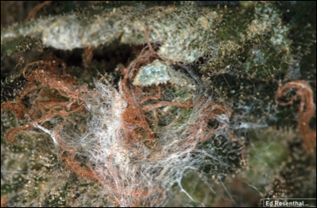
Figure 18.1. Aspergillus mold growing on dried Cannabis flower.

If Cannabis flower has been dried and stored properly, it can last for long periods of time with little risk to fungal attack. As long as no moisture is added back to the material, fungi will not be able to grow on the relatively dry flowers. Glass jars with caps that screw on tightly work well for long term storage of Cannabis. On a larger scale, food grade 5 or 55 gallon buckets with airtight lids can be used to store material in relatively good condition, if they are placed in cold storage or buried underground for temperature control. Purging ambient air from storage containers by injecting nitrogen gas can lengthen shelf life by minimizing oxidation in storage.
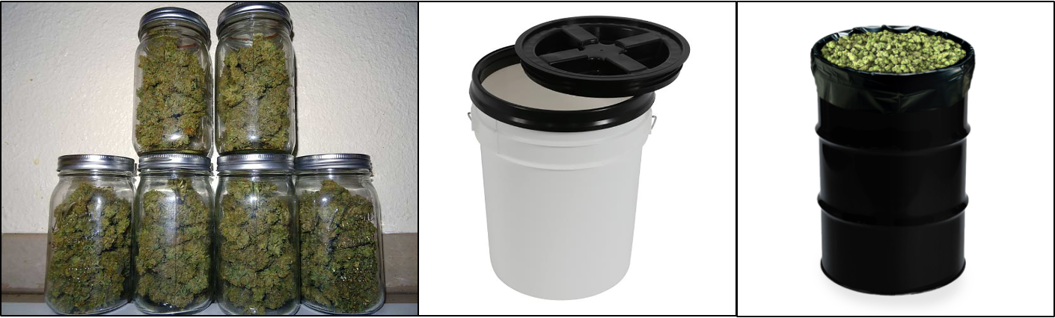
Figure. 18.2. Common ways of safely storing Cannabis flower long term.

As long as certain parameters are met, product loss to mold among plant material that has already been cut down should be minimal. The first few days represent a short window of time where mold may continue to grow. Moisture within the flower should be dropped relatively quickly at first, in order to reach a point impermissible to significant mold growth.
Many food industries will measure the water activity of particular products to determine how susceptible products are to microbial growth. Although water activity is related to moisture content, the two are not synonymous. Moisture content refers to the amount of water that is in the material being measured and is usually expressed as a percentage. Water activity is slightly more complex and represents the partial vapor pressure of water within a material divided by the partial vapor pressure of water at a given temperature (Table 1). Water activity is expressed on a scale of 0-1, with 0 being bone dry and 1 being pure water. Water activity ultimately measures the amount of free water that is not bound to material and is available to microorganisms for their life processes.
Table 17.2. Water activity is a measure of vapor pressure within drying Cannabis flowers divided by the partial vapor pressure of water at the same temperature.
aw=p/p*
aw= water activity | p= partial vapor pressure within the flower | p*=partial vapor pressure of water at a given temperature

A water activity monitor may be used to ensure proper moisture content benchmarks are reached. Flowers should be dropped to 0.8 quickly, within a few days at most. Once this point is reached, drying should proceed slowly and at a cool temperature for up to several weeks. Most mold is unable to grow at a water potential under 0.7 and flowers should reach about 0.6 before it is ready to be moved to the curing stage. Oregon and California mandate that flower must have water activity under 0.65 to prevent spoilage. For comparison, distilled water has an a_{w} of 1.0 and dried fruit an a_{w} of ~0.6.

Table 17.3 Water content benchmarks through the drying process.
Stage | Water activity (preferred) | Moisture content⁴
fresh | >0.9 | 90%
drying | <0.8-0.65 | <16-12%
curing | 0.7-0.6 | 12-11%
storage/use | <0.65-0.6 | <12-10%

Water activity monitors can range from several hundred to thousands of dollars and are the preferred method in industries with precise drying and storage requirements. On the other hand, moisture content, the measure of water in a sample as represented by percent weight of water, can be approximately measured at home very cheaply: weigh a sample of Cannabis, dehydrate it fully in an oven or dehydrator, and reweight the dry material. The difference in weight between the fresh and dry sample, divided by the weight of the fresh sample and then multiplied by 100 percent is the moisture content (Table 17.4).
Table 17.4. How to measure the moisture content of Cannabis flower.

- Weigh out 100g of flower
- Heat oven to lowest temperature (<200ºF)
- Put flower in oven for 2 hours
- Remove from oven and re-weigh material
- ((Fresh Weight - New weight)/Starting Weight) X 100%=Moisture content

Eg. I have a 100 g sample of Cannabis flower. After dehydrating the sample, the flower weighs 85 grams:

((100-85)/100) X 100%= Moisture content
(100-85)=15
((15)/100) X 100%=MC
(.15) X 100%=MC
Moisture Content=15%

Ed Rosenthal has suggested using a wood moisture meter for tracing water loss through drying and curing (Rosenthal 2017). Wood moisture meters are designed to measure wood density and temperature, and therefore will only ever approximate true water content, but nonetheless may be informative for tracking water content of drying Cannabis if it remains consistent. Wood moisture meters can be purchased for less than $50. Moisture content is less informative than water activity for spoilage prevention; low moisture content material may still spoil if the water present is not bound, and therefore free for use by microbes for growth.
Growers should experiment with manipulating their dry room temperatures, dehumidification, and air exchange to best reach optimum drying time. The traditional rule has been that the dry room should be kept at 60% relative humidity or less with a temperature below 60ºF. These parameters may allow too much time for mold growth in some circumstances. The relative humidity can be dropped significantly below 60% during the initial stages of drying to speed through the vulnerable stage of drying. Circulating fans should be used to prevent any stale pockets of air from occurring. Low temperature environments will discourage fungal growth while providing an optimum environment for maintaining flower quality through the drying process, allowing the Cannabis flowers to ‘slow dry’ for a smooth and aromatic final product. (Table 17.5).

Table 17.5. Environmental parameters for drying Cannabis flower to ensure no loss to mold post-harvest
Relative humidity | <60%
Temperature | ~<60oF
Air movement | Steady movement, no still pockets
Lighting | Kept Dark

There is some debate about the processes occurring during the dry and cure process of Cannabis. There are chemical changes that occur in the flower post harvest, though there is little Cannabis- specific research. Tobacco has received more attention for legal reasons, obviously. Curing tobacco experiences a decrease in chlorophyll and starches during curing, with an increase in sugars (Yamaguchi et al 2013). Various reactions occur, including Maillard reactions between amino acids and sugars; nitrosamine formation from the combination of nicotine and nitrates; phenylalanine degradation from which volatile phenols are produced , as well as isoprenoid and carotenoid oxidation (Zhu et al, 2016). Different methods are used to cure tobacco, from a slow air-cure similar to traditional Cannabis drying, to methods that add heat, including sun-curing, flu, and smoke curing. Air-cured tobacco has the lowest amount of sugars, compared to methods that add heat.
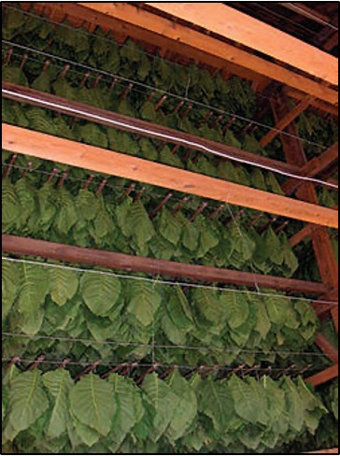
Figure 18.3. Tobacco hung and air dried in a barn.

Farmers are often solely focused on terpene content through the grow and drying cycle. The high terpene content and its large effect on the aroma of Cannabis is different from tobacco, and is one of the reasons tobacco curing is different; the high heat used in tobacco curing would be totally unacceptable for Cannabis. However, a wide range of other chemical compounds, including phenols, acetyls, ketones, thiols, esters and more, combine to produce the final scent of Cannabis. The chemical profile of Cannabis continues to develop through the dry and cure processes. Carotenoid (tetraterpenoid) oxidation, for instance, produces the “rose ketones,” ionones, damascones and damascenones. These are important fragrance chemicals, responsible for much of the characteristic scent of a rose (Yue et al 2016).
Freeze-drying Cannabis has gained attention as a means to achieve high-quality flower and extracts. If terpenes and other volatiles present in freshly harvested material are the major drivers of organoleptic quality, freeze-drying may prove itself as the best way to dry Cannabis. The rapidity and low temperature process also has reduced risk of mold-losses over traditional slow-drying.
If you are unconcerned with the smokeability or the organoleptics of your final product, you may benefit from the addition of heat for drying. Large scale hops dryers have been adapted for Cannabis on hemp farms that are producing huge quantities of biomass solely for extraction of CBD and other cannabinoids. Most cartridges for vaporizer pens in the THC market are also produced from distillate and/or isolate where the quality of the flower from which it is derived is mostly irrelevant (though higher quality and healthy plants will likely possess more cannabinoids). Among isolate and distillate processing operations, even the presence of mold matters little. Though, mold will affect the grower and processor in terms of lost mass of THC/CBD. For processing techniques that do not purify the resulting concentrate into fractions, processing flowers with contaminant mold concentrates any mycotoxins that may have been produced.
If, despite meeting the aforementioned drying room parameters, molds are found on the flower after drying, it is likely that the fungus was mostly growing while the plant was living. Some fungi are quite inconspicuous on the growing plant and oftentimes are overlooked by the grower. These fungi are frequently from the genera Aspergillus or Penicillium and may act as endophytes or latent saprophytes.
Most fungi that affect Cannabis are generally benign to humans. This includes the ubiquitous Botrytis and Powdery Mildew fungi (Erysiphales), though the inhalation of large quantities of spores may cause respiratory issues and all fungi may elicit allergic reactions in some people. Of greater concern to human health, several fungal species that occur on Cannabis are capable of producing very dangerous mycotoxins and/or directly causing human disease. Species of both Aspergillus and Penicillium that produce toxic compounds are able to grow on Cannabis as contaminants and endophytic symbionts (Mckernan et al. 2015;, Taghinasab and Suha Jabaji, 2020). Some species of these same genera, and others such as Cryptococcus and Mucor, known to cause human disease have also been found on and within Cannabis flower intended for human consumption (Thompson et al 2017, B. Shapiro et al. 2018; Scott et al. 2018)
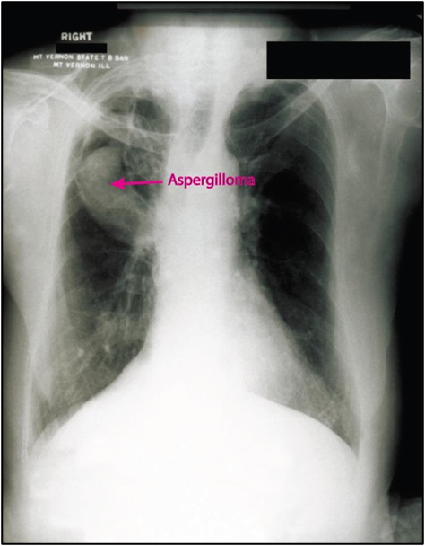
Figure 18.4. Aspergillus fungus growing a ‘fungus-ball’ or aspergilloma in the lung of a patient with a compromised immune system.

Aspergillosis is a disease caused by some members of the genus Aspergillus. This results in a pulmonary infection, where fungal mycelium begins to grow in the lungs, which can lead to fatalities. Death from aspergillosis has been reported among immunocompromised people that may have been linked to exposure to Aspergillus contaminated Cannabis (Gargani et al. 2011, Remington et al. 2015). With this disease the fungus can begin to grow and colonize the lungs and penetrate nearby tissue in a three dimensional colony called a fungus ball. Additionally, exposure to moldy Cannabis flower has been associated with allergic bronchopulmonary aspergillosis, an autoimmune response to various Aspergillus species (Llamas et al. 1978).
Exposure to Aspergillus propagules in the environment is ubiquitous; you are likely breathing in and out spores at this moment. Most people without suppressed immune systems are usually unaffected by this onslaught. However, moldy Cannabis may contain such high numbers of pathogen spores that it overwhelms people (even otherwise healthy people) or triggers a runaway immune response in those with potential allergies. A case of cryptococcal meningitis in an apparently non-immunocompromised, daily Cannabis smoker was putatively linked to the consumption of smoked Cannabis flower (B. Shapiro et al. 2018). Mucormycosis, caused by species within the genera Rhizopus and Mucor, can be a severely disfiguring and often fatal infection, several cases of which have been linked to medical Cannabis use in diabetic patients (Stone et al 2019). For severely immunocompromised people, fungi that rarely cause human pathogenesis, such as Fusarium sp. inhaled from herbal Cannabis use, can cause fatal pulmonary infections (Khwaja et al. 2016). One of the most common fungal general found on a sampling of California dispensary Cannabis was Purpureocillium (Thompson et al. 2016). Purpureocillium is an emerging human pathogen that can cause pulmonary infections (Salazar-González et al. 2020) Due to these serious threats posed by consuming fungally contaminated products, it is of utmost importance that Cannabis products be screened and tested for the presence of these organisms, and to be grown and processed in a manner that reduces the occurrence of dangerous molds in the first place.
Microbial testing for Cannabis products varies from state to state. Some states do not perform any sort of microbial test, but instead measure water activity and moisture content as a proxy to infer how likely microbes will be to grow on the tissue. However, there are not yet standard definitive methods for detecting harmful pathogens on flowers, let alone distinguishing them from benign microorganisms. As the industry develops, testing methods are likely to follow suit and become more rigorous and accurate at identifying harmful organisms. Species specific assays, based on metabolic tests and base sequence analysis, are being developed for use among Cannabis samples. Until such testing methods are widespread, we are left to imperfect screening and the use our senses to examine our products before consuming them. If there is concern the product may be contaminated or if the end user is immunocompromised, particular caution should be exercised.
Many options exist for post-harvest sterilization of flower and other Cannabis products. Various methods of extraction and purification can be used to recover cannabinoids and terpenes from contaminated flower. Ensuring that unprocessed flower intended for inhalation is not a microbial risk is more difficult than creating clean extracts. Most available methods for flower remediation, particularly those available to small growers, will degrade quality to some (sometimes large) extent. Commercial sterilization products developed for the food industry cause much less damage to the organoleptic quality of the products, though they can be prohibitively expensive (Table 17.6).
While some connoisseur consumers will be wary of any loss of quality compared to raw products, others must insist on the elimination of any pathogen risk. Farmers should consider consumer needs across the entire market and anticipate customers who require or desire sterile products. In some jurisdictions, regulations set minimum standards for microbial contamination to which farmers must adhere. In jurisdictions that use nondiscriminatory total yeast and mold counts (TYMC) rather than pathogen specific screens, post harvest remediation may be required regardless. This is especially of concern for outdoor crops which are exposed to high ambient inocula and air filtration and sterilization are not options.

Table 17.6. Sterilization methods for Cannabis flower. Radio frequency and e-beam radiation have both been reported to remediate Cannabis flower without unacceptable losses in quality.
Category | Method | Benefits | Negatives
Extraction | hydrocarbon, alcohol, CO2, distillation | - Accessible to all scales  - Produces high quality extract product | - Flower may be a preferable product  - Some infrastructure investment and knowledge required  - May concentrate pesticides and mycotoxins
Heat treatments | Steam, autoclave, pressure cooker, dry oven | - Highly effective at destroying nearly all biological contaminants | - Destroys flower  - Degrades and alters cannabinoid content
Non-ionizing radiation | Microwave, Radio frequency | - Capable of sterilization throughout an entire flower sample, not just the surface  - Much less damaging than direct heat treatments | - Degradation in organoleptic qualities still occurs, including losses of terpenes
Ionizing radiation | Gamma, X-ray, electron-beam | - Capable of sterilization throughout an entire flower sample, not just the surface  - Much less damaging than direct heat treatments | - Degradation in organoleptic qualities may still occur, including losses of terpenes  - Gamma radiation requires dangerous radioactive material

Sight, smell, feel, and taste are among our direct innate senses which we may rely on to screen contaminated products before use. If we see any fuzzy or furry growth on the material, that is indicative of the presence of a young fungal colony. Sometimes when we break open a bud it feels especially dry and crumbly. Or maybe it feels soft and tears more than snaps. Either of these can be indicative of fungal contamination. If the flower feels or looks different for some reason, inspect it further before consuming it.

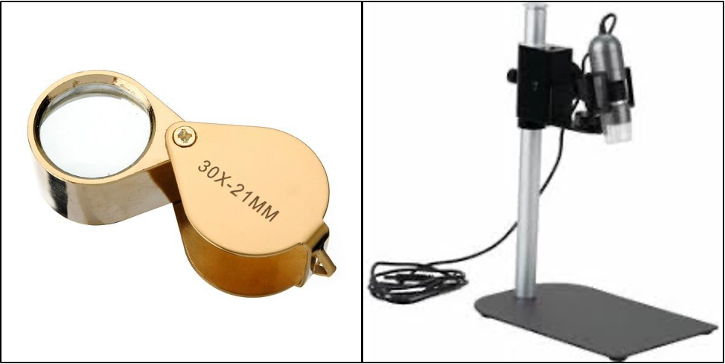
Figure 18.5. Tools used to closely inspect Cannabis flowers; Jewelers loupe (left) and USB digital dissecting scope capable of taking pictures (right).

Eventually you may also be able to see conidia or spore bearing structures forming on or within the flowers. Sometimes these can look very similar to trichomes to the naked eye. Often it is not until we magnify what we are consuming that we are really able to see the contaminate. Using a jeweler's loupe or dissecting scope is a good way to differentiate minor mold contamination from desirable trichome coverage. If conidia are well developed, you can often see a cloud of spores injected into the air when you tear a bud apart. Trichomes may also break off in burts from dry flowers, but these will quickly fall downward with gravity. Spores, having evolved to ride air currents, tend to rise upward; appearing as a puff of smoke. Smelling for mold is a little trickier, but molds release volatile organic compounds with generally unagreeable scents. If flower smells damp or off, this could be a clue that mold is growing and the Cannabis should be discarded.

